Why did the Welsh leave Wales?
This session is more about where did your ancestors come from, not where did they go to
Dr Penny Walters
PhD, MSc., BSc. Hons., Grad. IPM., Dip.HEd., PGCE, PGCert. Genealogy
penny_walters@talk21.com
www.searchmypast.co.uk
Outline
This session will look at why the Welsh left Wales during the 1800s, specifically to go to America, in search of a better life, and the freedom to express their religious views.

Background inspiration
The wife of my DNA match wanted some background information about their Welsh ancestors.

Background context
Immigrant ancestors are inspiring & fascinating because they are diaspora (left somewhere) and pioneers (came to somewhere). We would like to know how, when and why ancestors went to America.

How do you know your ancestor was from Wales?
This might be a mix of an established family tree, family lore, Bibles, naming traditions, photographs, letters, food, Naturalisation records, census information, collaboration, BMD records, specific words used in family, music, dance, connected family trees, and/ or DNA test results.

Where is Wales?
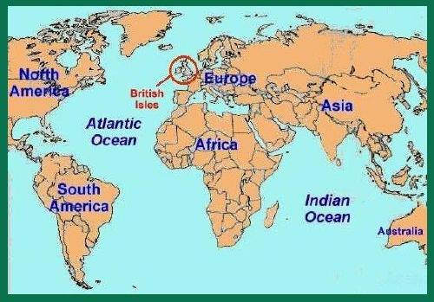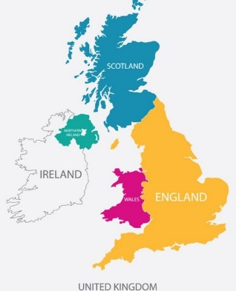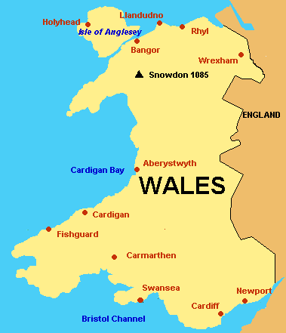

Wales, England, Scotland and Northern Ireland (Ulster), make up the United Kingdom of Great Britain and Northern Ireland. Great Britain, together with the Republic of Ireland (Eire), form the geographical grouping known as the British Isles. Wales is not part of England.

The Counties of Wales https://www.genuki.org.uk/big/wal/GHP/welshcounties
Wales is divided into administrative districts – ‘counties’ which were created by the Acts of Union (1536-1542) during the reign of Henry VIII. New counties were created in 1974 (9 in total), and revised again in 1996 (22 total). The Welsh language is spoken with a different accent in North, Mid or South Wales. https://www.jlb2011.co.uk/wales/sounds/index.htm

Montgomeryshire
GENUKI: Montgomeryshire, Montgomeryshire
"The County of Montgomery is 94 Miles in Circumference, contains about 500000 Acres, is divided into 7 Hundreds, in which are 6 Market Towns, and only Montgomery sends a Member to Parliament, which is the County Town, 47 Parishes and about 5660 Houses. The air is sharp and cold by reason of its high situation, the Valleys are very fertile, breeding very good Horses and plenty of Goats. The soil is stony, mountainous and rocky, intermixed with pleasant Bottoms. Its chief Commodities are Flesh, Fish, Fowl and all manner of Grain for the use of Man &c." [Emanuel Bowen, Britannia Depicta, 1720]
"Montgomeryshire, an inland county of North Wales, bounded on the N. by Denbighshire, on the S. by Radnorshire, on the E. by Shropshire, and on the W. by Merionethshire. It is in the form of an irregular parallelogram, being 37 miles in its greatest length, and 29 miles in its greatest breadth. It has a circuit of 135 miles, and an area of about 840 square miles, or 483,323 statute acres, of which nearly one-half is waste or common, and the remainder pasture and arable. It is divided into nine hundreds, viz: Llanfyllin, Mathrafell, Deythur, Welshpool, Cawrse, Machynlleth, Montgomery, Llanidloes, and Newtown, which are again divided into 48 parishes, besides parts of some others..." Description(s) from The National Gazetteer of Great Britain and Ireland (1868)
Map from 'A Topographical Dictionary of Wales' by Samuel Lewis 1833

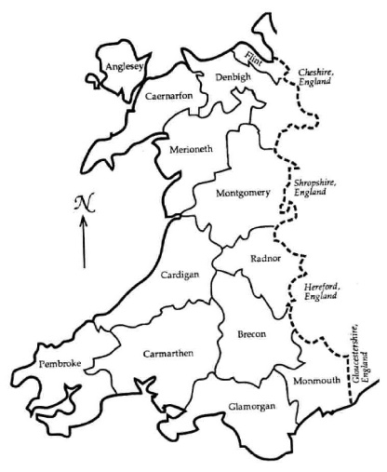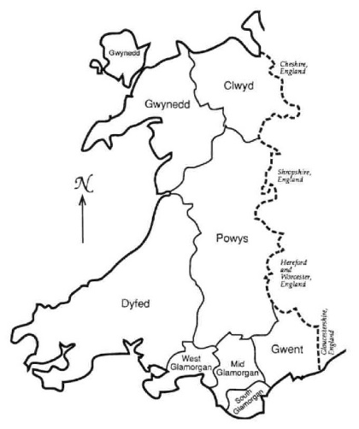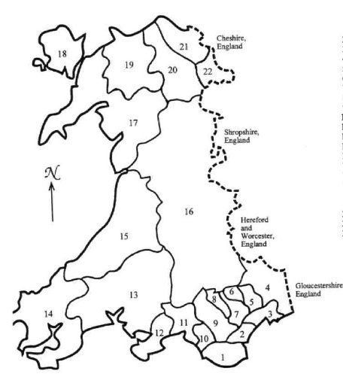
before 1974 1974-1996 after 1996

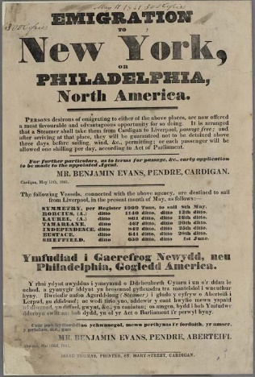
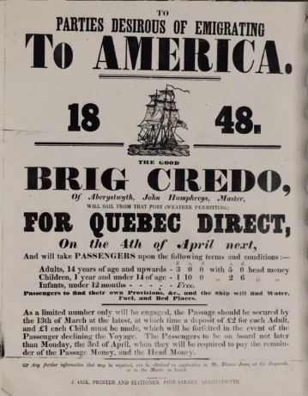
Historical overview: 1750-1950

Before 1750 rural, farming people
1750–1800 Early Industrialisation
1800–1825 Welsh Identity
1825–1850 Mining, social unrest, emigration
1850–1875 Economic boom
1875–1900 Mining
1900–1925 Population shifts
1925–1950 The Great Depression

Can study and deconstruct the information given on Emigration posters.

Emigration to USA
- Pennsylvania - Quakers, mining
- Utah - Welsh Mormon Immigrant project http://welshmormon.byu.edu/
- Ohio - railroads, mining

Surnames https://named.publicprofiler.org/
Named Maps places in the UK where surnames have a historically unusually high local population.

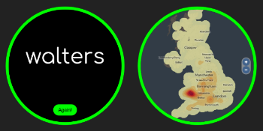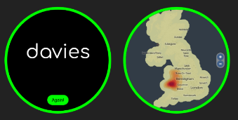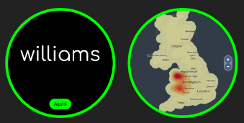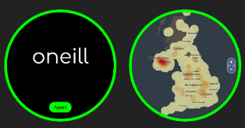

DNA testing
Some DNA testing companies will give Wales as an ethnicity, and even pinpoint regions. You can collaborate with matches.

 | Penny | Child 1 | Child 2 | Child 3 | Child 4 | Child 5 | Child 6
Ireland | 94 | 64 | 45 | 46 | 50 | 50 | 41
Wales | 6 | 16 | 37 | 36 | 0 | 0 | 9
Other | 0 | 20 | 18 | 18 | 50 | 50 | 50

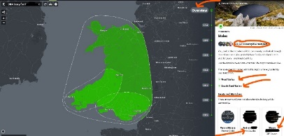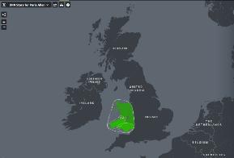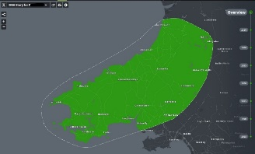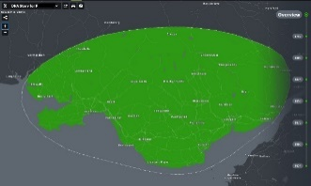

Censuses taken every 10 years from 1801 to present. Pinpoint useful information.
- 1801 - 1831 - statistical summaries
- 1841 - 6 June - place, name, age rounded up/ down, sex, work, born
- 1851 - 30 March - plus relationship, ‘condition’ (S/M/W) where born
- 1861 - 7 April - plus disabilities
- 1871 - 2 April - plus lunacy
- 1881 - 3 April - same as 1881
- 1891 - 5 April - plus employment detail, language/s spoken
- 1901 - 31 March - plus employer/ work at home
- 1911 - 2 April - page per household, years married, children alive & dead, signature
- 1921 census - released 1 January 2022 (Find My Past)
- 1931 was destroyed by fire
- 1941 no census was taken ** 1939 Register can be used as a substitute **

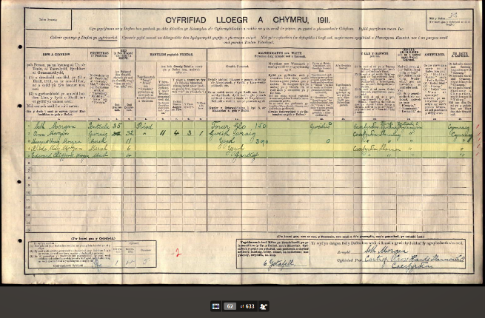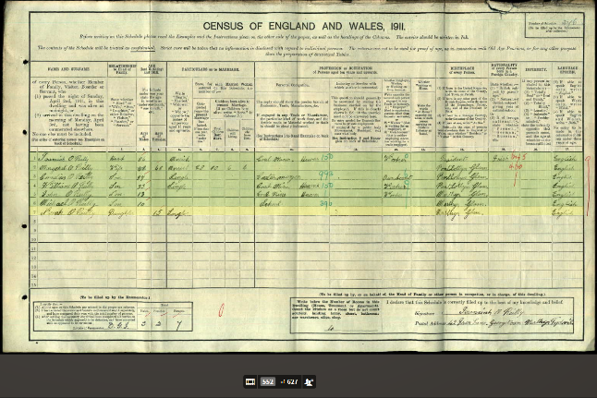
You could compare an English census with one written in Welsh, looking at the columns or use a translation tool. https://translate.google.com/

Welsh language
- 2001 - 21% of residents in Wales aged 3+ speak Welsh (UK Census)
- 2011 - 19% (UK Census)
- 2019 - 28.4% (The Annual Population Survey conducted by O.N.S.) plus 16% had some Welsh speaking ability

Useful words
- cyfrifiad - census; Yfrifiad Lloegr A Chymru - The England and Wales Census
- enw a chyfenw - name and surname
- marital status: priod - married, heb briod - not married, sengl - single
- relation to head: penteulu - head of family; gwraig - wife; merch - daughter; mab - son
- ysgol - school; yn ysgol - at school; plentyn ysgo - schoolchildl; ysgolhaig - scholar
- gartref - at home; gweith - work; gweithio - working; gweith wraig - work woman
- tymawr - big house

Traditional foods:
- cawl - classic 1 pot - soup or stew made from any meat (lamb) plus vegetables, leeks
- laverbread - ‘Welshman’s caviar’ – fried seaweed
- Welsh cakes – ‘Welsh pics’ – similar to a mix of cookie, scone, pancake
- bara brith - fruit bread
- oggie - lamb, mint, potatoes, onions, leeks

Individual accounts
For example, ‘From Rhosfach to Prairie Union’
https://journals.library.wales/view/1319198/1322310/228#?xywh=-2974%2C-268%2C8931%2C4527
You can extract lots of information from this autobiography written from a diary, then research clues within.

Celebrities
You can watch and make notes from episodes of ‘Who Do You Think You Are,’ which feature celebrities with Welsh heritage, such as:
- Colin Jackson - Series 3, episode 3, British sprint & hurdling athlete
- Griff Rhys Jones – Series 4, episode 3, Welsh comedian, writer, actor & television presenter
- Carole Vorderman - Series 4, episode 4, British media personality, author
- Greg Davies - Series 13, Episode 7 - stand-up comedian & actor
- Fearne Cotton - Series 14, Episode 7, 2017 - TV & Radio presenter

New celebrity - Ffion from Furnace
- No Holiday for Ffion: https://www.youtube.com/watch?v=nhy4lOk4prw
- Dr Ffion: https://www.youtube.com/watch?v=8iB_kKxGXYQ

Facebook pages
- Wales/ Cymru Welsh images & stories; https://www.facebook.com/groups/179977289307211/
- West Glamorgan Archive Service: https://www.facebook.com/WestGlamorganArchives/
- Llanelli Unseen photo forum: https://www.facebook.com/groups/218378588737055/
- The People’s Collection Wales: https://www.facebook.com/pplscollection/
- Welsh Genealogy: https://www.facebook.com/groups/291492577588085/

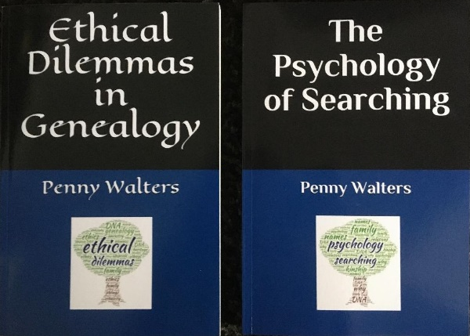
Stay in touch:
email: penny_walters@talk21.com
website: http://www.searchmypast.co.uk/
FB: https://www.facebook.com/penny.walters.52
FB Business page: https://www.facebook.com/searchmypast/
Follow on Instagram: https://www.instagram.com/penny.walters/?hl=en
Join Network on LinkedIn: https://www.linkedin.com/in/dr-p-walters-19702759/
Twitter: https://twitter.com/DrPennyW

